Chapter 5, Problem 90

The op amp circuit in Fig. 5.107 is a current amplifier. Find the current gain i_{o}/i_{s} of the amplifier.
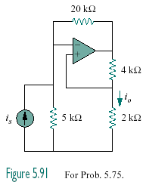

Figure 5.107
For Prob. 5.90.

